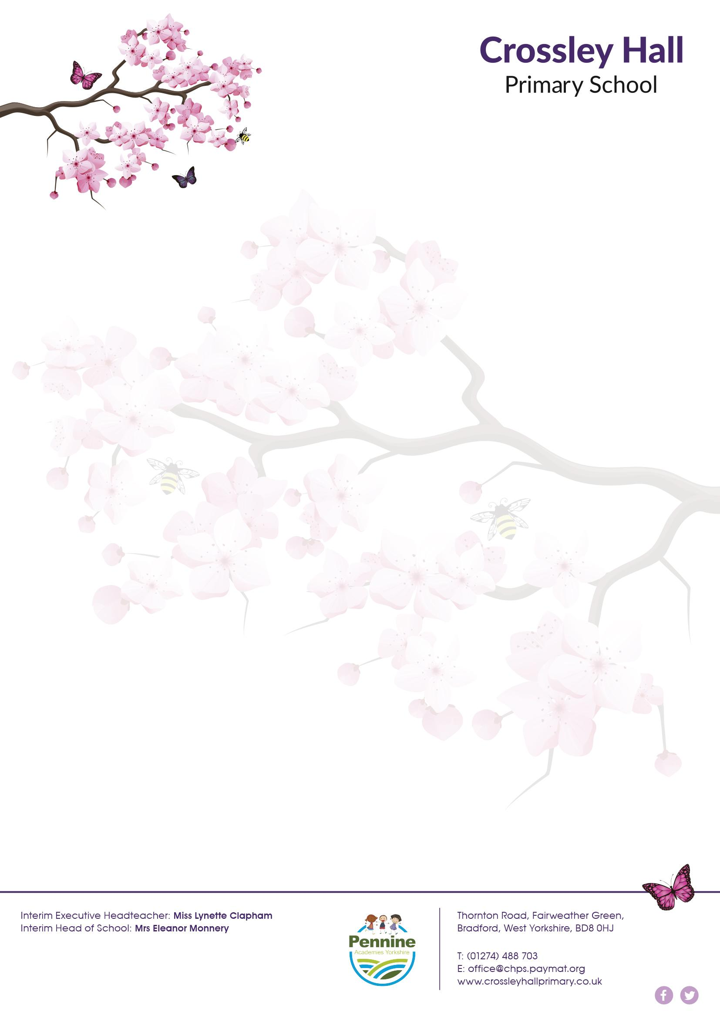
Dear Parent/Carer Tuesday 2nd November 2021

After School Sports Club – Year 3 Golf Club
Autumn 2
Here at Crossley Hall Primary, we are passionate about ensuring that our pupils have access to a wide range of additional experiences to enhance and enrich our curriculum. Therefore, in addition to Homework and Breakfast clubs we have developed some exciting opportunities for your children to take part in various After School Sports Clubs.
Year 3 have been given the opportunity to attend a Golf Club every Thursday from the 11th November until 16th December from 3:00pm-4:00pm. They will have a specialised coach delivering the sessions. Spaces are limited to 14 so please email adminteam@chps.paymat.org if you would like your child to attend before Thursday 4th November.
Please note: All those children who attended after school clubs last term will not be able to attend this time. This will allow all children to have a chance to attend.
Thank you for your continued support
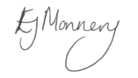
Eleanor Monnery
Head of School

