Crossleygraph School Council News
Autumn Term 2021
Introducing your new School Council
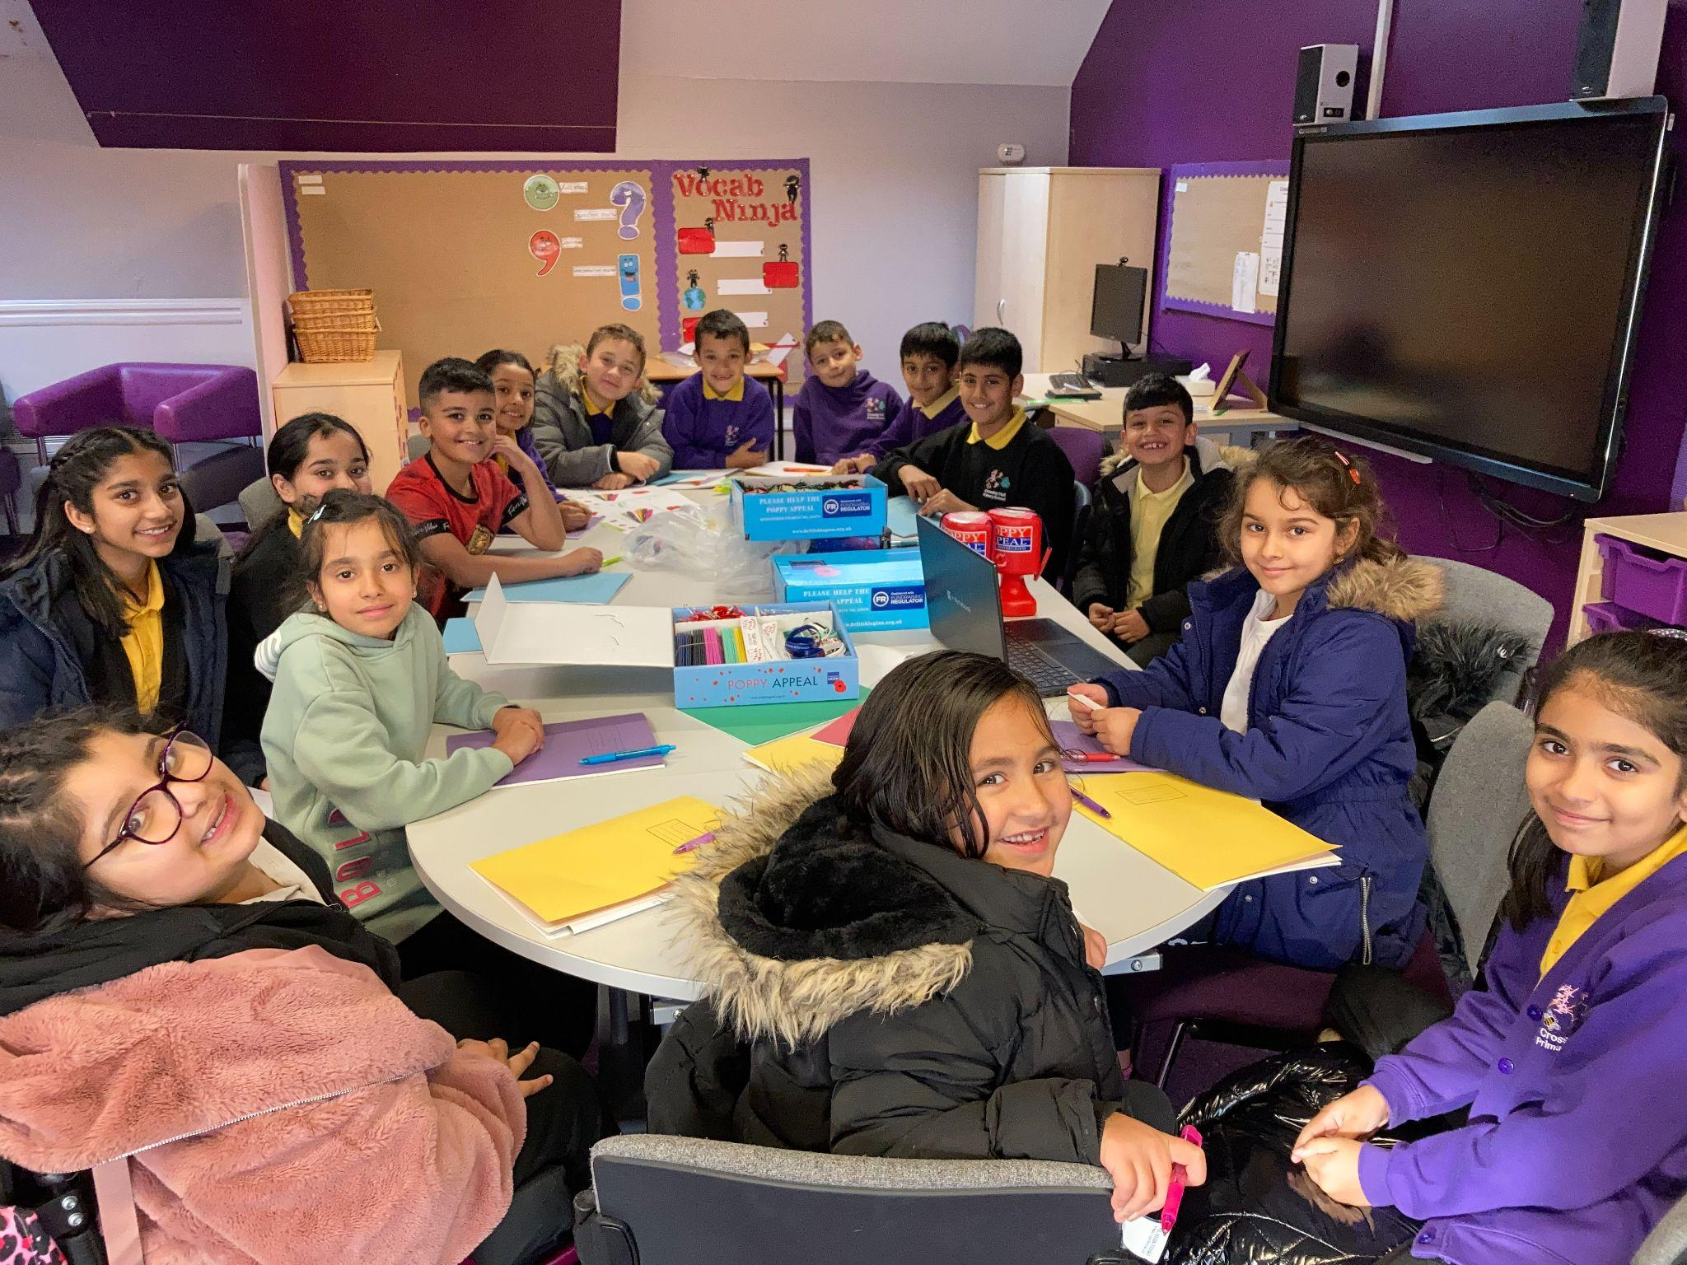
The School Council is a group of children who meet and talk about ways to help other children in our school. Every child in Year 2 to Year 6 was invited to put themselves forward to be a School Councillor for their class. Each class then voted who they would like to be their School Council representative.
The School Council team are planning to do lots of things to help our school. This is what we have done so far this term...
Poppy Sale  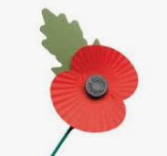  Hi everyone, our school raised an amazing £559.58 for the Poppy Appeal, the most in the area! Thank you everyone for supporting this.  By Aminah Noor Rani, 3M School Councillor | Children in Need  The children in need colouring competition was a great success. Children were asked to bring in any coin and we raised the great amount of £19.58  By Isaiah Clavecillas, 5T School Councillor
Anti-Bullying Team
The Anti-Bullying team has been set up. To begin with, The School Councillors are helping the children at lunchtime to make friends and solve problems. Watch this space for news about how other children in our school can join our team!
By Halima Sadia, 4P School Councillor
Pupil Voice Survey
On Monday 22nd November Mrs Monnery came to ask our opinions about teaching and learning in our school. We all agreed that we know who to speak to if we do not feel safe in school and we talked about how we can make our school an even better place to play and learn. By Mrs Annetts, School Council Leader

