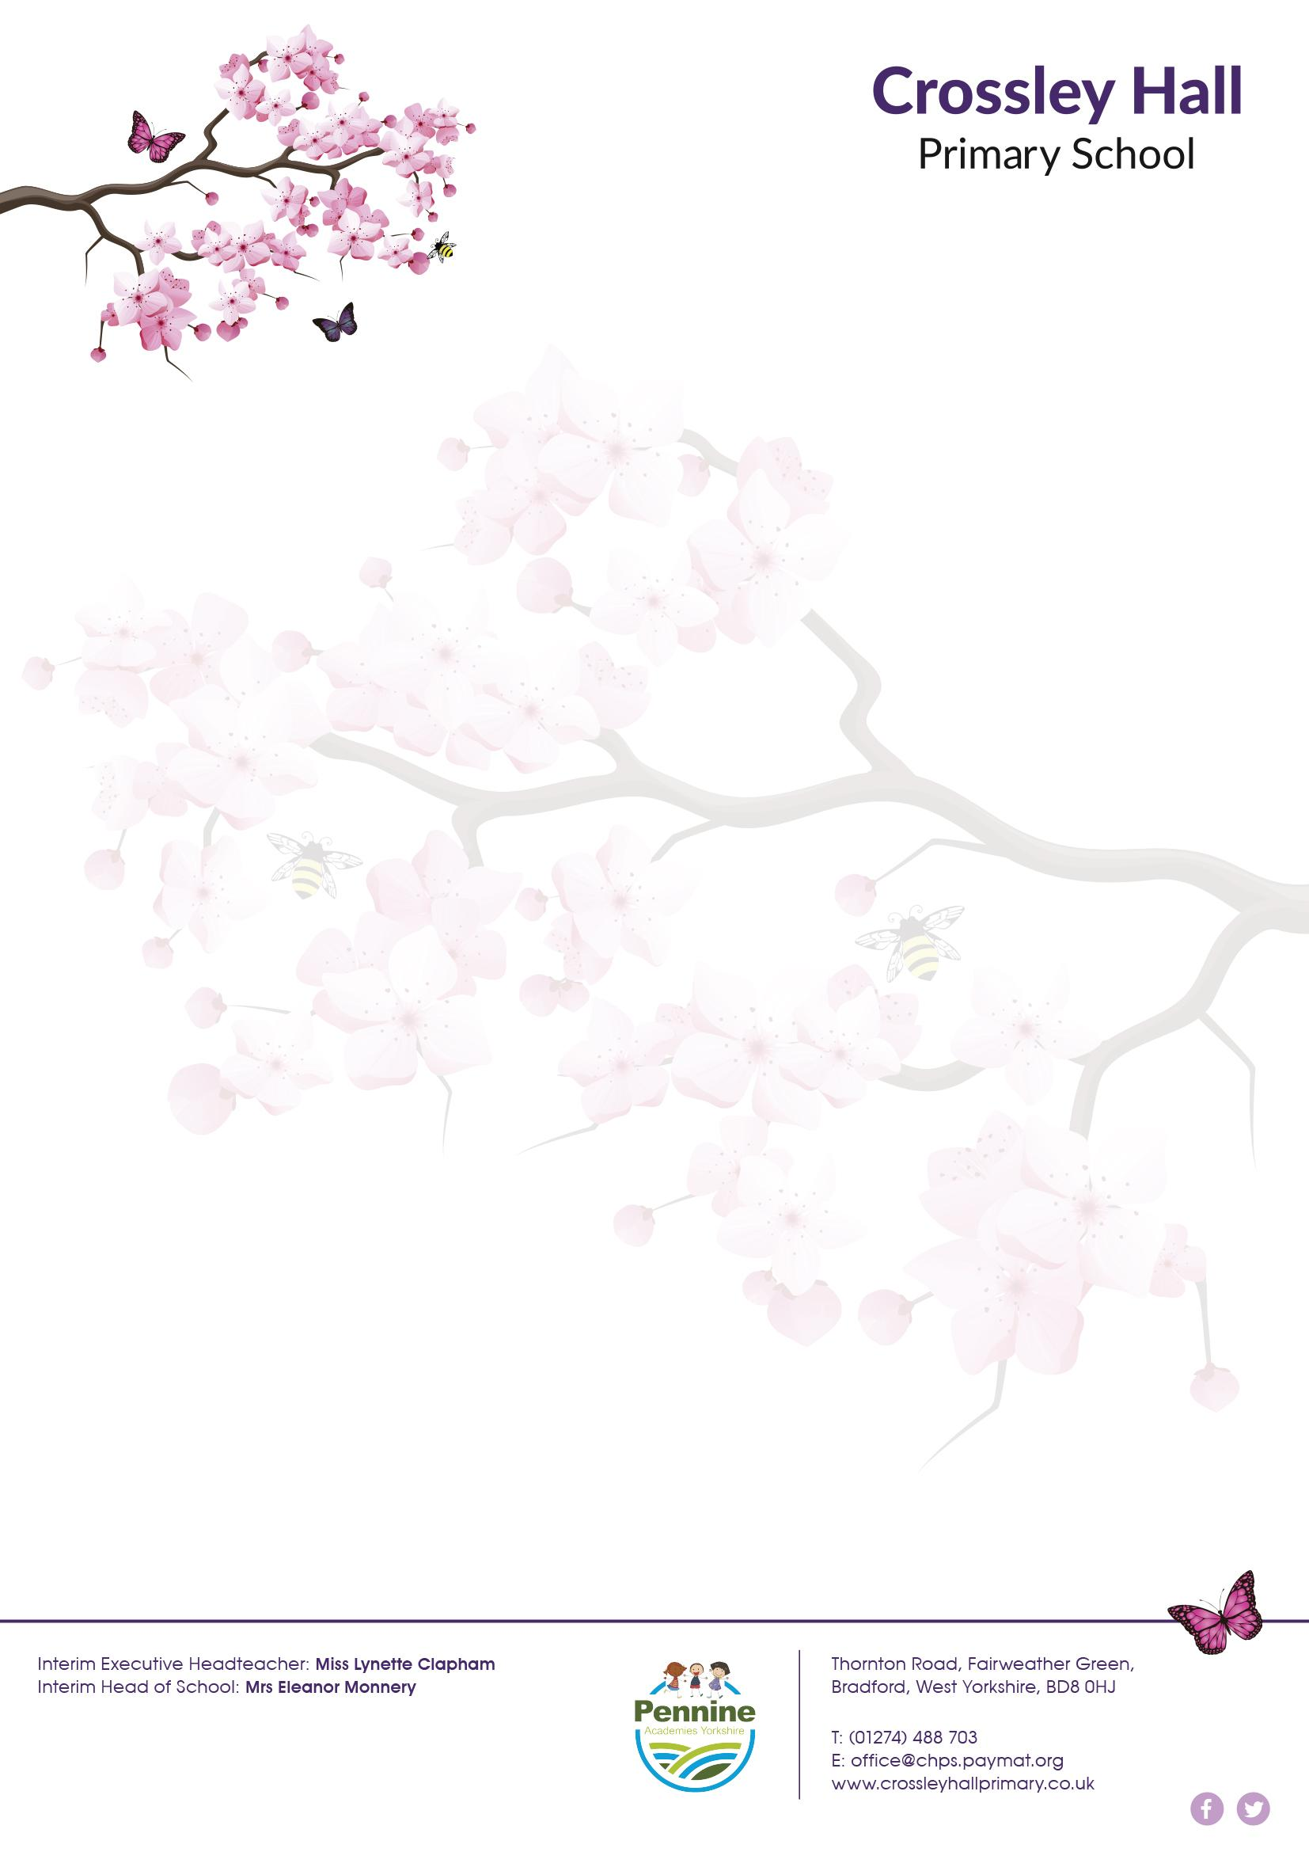
Dear Parents/ Carers Tuesday 14th December 2021

I am writing to update you on staffing in your child's class.

I can now confirm that Miss Oldcorn will not be returning to her position at Crossley Hall. I would like to thank her for all she has done for our children in the time she was with us and wish her the best of luck in her next adventure.

As school reopens in the New Year, we are looking forward to welcoming Miss Begum to Crossley Hall as the full time class teacher in 1H. Miss Begum is very excited to join the team. She brings with her a passion and excitement for learning and will deliver consistent teaching and learning from January onwards.

Before the end of term, Miss Weston will be contacting all parents via telephone with an update of how your child is working in school. She will also support the handover process to your child's new class teacher so everyone is as prepared as they can be.

I would like to thank parents for bearing with us during these challenging times and wish you all a restful and pleasant Christmas break.

Yours sincerely

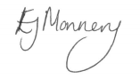
Eleanor Monnery
Head of School

